Report: Selling Price and National Market Analysis for D.M. Pan National Real Estate Company
[Your Name]
Southern New Hampshire University
Introduction
The realtors in the real estate sector need to make sure that the house prices are accurate and reflect on the different architectural factors such as design, location, and year of construction. Putting such factors into consideration ensures that house buyers are getting value for their money. To successfully achieve consumer satisfaction, they utilize different information like regression models used in analyzing the existing correlations between the factors at hand. Linear regression is the most relevant model, especially when the response and predictor variables have a linear correlation. The best way to determine linear correlation is by plotting a scatter plot and then assessing whether or not it shows a linear pattern. The aim of this analysis is to assess the medium square feet as determinant of the median listing prices of houses.
Data Collection
Data Sampling
The Real Estate County Data was used in the selection of a sample (n = 50). The RANDBETWEEN excel function was used to randomly select the data samples. The technique ensured that every information present in the listing had an equal chance of selection in the analysis. Table 1 below shows the sample data.
Table 1: Representative sample for the analysis
Scatterplot
A scatterplot of the data that has been sampled showed whether the two variables had a linear correlation. Scatterplot utilizes the distribution of data in estimating the linear line spanning across different values. The scatterplot of the median listing prices and median square feet have all been demonstrated in the figure below.

Figure 2: Distribution of Median Square Feet
Data Analysis
Histograms

Figure 3: Distribution of median listing price

Summary Statistics
Table 2: Summary statistics for the sample data
Interpretation
The histogram is symmetric and bell-like in shape. The shapes indicate that the data sample of the variable is normally distributed. Most values have been placed around the middle, with just a few being seen on the distribution's left and right sides. The mean and median values in the square feet also demonstrate a symmetric distribution as they are close to each other with the median that is 1,848, while the mean is 1868 with a 341.9 standard deviation.
The histogram for the median listing price is observed to have a longer right tail. The long trail indicates that the data in the variable is skewed to the right. Some of the unusual values in the sample include $755,142 that is pulling the mean up. Additionally, there are significant gaps from $531,542 to $755,142. For this reason, the mean automatically appears considerably more than the median of the sample.
The histogram from the sample data is similar to those of the national population. In the median listing price, the histogram is skewed to the right, which is also seen in the histogram for the national population. This indicates that a good number of the values are present on the right side of the graph, with a few being large in an unusual way. additionally, it indicates the differences between the median and means for variables with a larger mean than the median. The medium square feet histogram in the sample data appears to have a symmetrical shape, thus indicating a distribution that is normal. The median and mean for the median square feet variable are close to one another with no difference from the national data.
Regression Model
Scatterplot
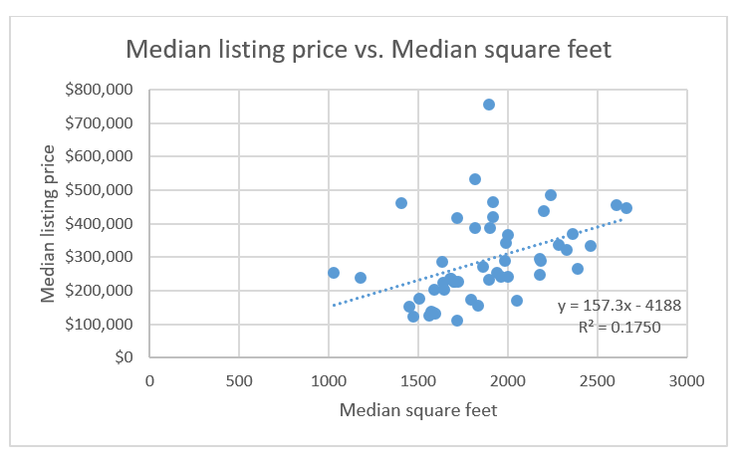
According to the scatterplot demonstrated above, the regression model is not recommended to develop the sample data utilized. The relationship between the two variables observed from the scatterplot above is positive with an increase in the median square feet, leading to the rise in the median listing price. This can be inferred from positive slope. However, as observed in the small value of coefficient determination (R²), the correlation is weak, which is about 0.1750 or 17.5. The weak correlation results from the outliers in the sample data. The correlation could be strengthened by removing the outliers, which will give the sample data a more linear pattern and a steeper slope. This will also promote the reliability of the regression model.
Correlation of coefficient can be obtained by first taking the square root of (R²), i.e., $\sqrt{0.1750}$, which is 0.418. When the correlation of coefficient is positive, it indicates an increase in the median square feet would facilitate a rise in the median listing price.
Line of Best Fit
The model's regression equation is y = 157.3x – 4188. In this regard, the equation demonstrates that an increase in the x variable increases the y variable (median listing price) by at least 157.3 times. In this case, the value of the intercept is also the value of bare land. The regression equation is then supported by an R² value of 0.1750. The regression equation be utilized in predicting the median listing prices of a home when its square feet are known. For instance, in a situation where the house is 1500 square feet, to obtain the listing price, the square feet will replace x in the regression equation. This will appear as follows: y = 157.3 (1500) – 4188, which will give a listing price of $231,762.
Conclusion
The median square listing price and square feet had weak correlation. Therefore, the model may not be used as the primary basis for valuing homes; other factors ought to be considered. These results negate the expectation that the square feet of the house would predict the listing price. Modifications of the model such as removing the outliers in the data could make the regression model stronger and more reliable. It would also be imperative to pose a follow up question in the model such as: Are there other factors that affect the median listing price of homes.

